Action Potential

Ahmed Emad Eldin
Ahmed Mohamed Mahmoud Elsarta
Marina Nasser Fayez
Maryam Megahed Gamil Abo-Donia
Magdy Muhammed El Sayed Nasr
Michael Hany Rofael Yousef
Mohamed Ahmed Ismael
Sherif Ahmed Elsayed Yousef
Department of bio-medical engineering
Supervised by
Dr. Samah Mohamed El Shafie
Professor of Electronics and Electrical Communications
Department
Faculty of engineering
Cairo university

Table of Contents:

- Abstract and introduction 3
- Literature review 4
- Mathematical modeling ……………………………………………………………………………………………………………………………………. 7
- Solution of Heimburg Equation ………………………………………………………………………………………………………………….……. 14
- Mathematical Solution …………………………………………….……………………….…………………………….………………. 15
- Numerical Solution …………………….…………………………….…………………………………………………….………………….. 16
- Scenarios …………………………………….…………………………………….…………………………………….………………………………………. 18
- Scenario 1 (Hyopkalemic periodic paralysis)………………………………………….………………………………………….... 18
- Scenario 2 (Brugada syndrome) …………..……………….…………………………….…….…………………………….………. 19
- Scenario 3 (Long Qt syndrome) ……………..…………….…………………………….…….…………………………….……….. 19
- Conclusion and future work .…………………………….…….…………………………….……………………………….……………………….. 21
- References ……………………………………….…………………………….…………………………………………………….………………………… 22

ABSTRACT

We will talk about action potential the universal biological signal for all organisms, it flows through neurons, muscle cells and so on.

We try to use transmission equations and the Hodgkin-Huxley model to mathematically model the propagation of action potentials as a function of time and distance.

Knowing the spatial and temporal distribution of the action potential of a specific disease can shed light on the physiological origins of certain diseases (Brugada syndrome, Hypokalemic periodic paralysis), and the proposed solution, which adjusts the ion concentrations in the body.

Introduction
The action potential is the messenger signal among biological organs (mostly going to and from the brain). This process is universal across organisms. It happens following stimulation of the nerve by a threshold stimulus. Then it propagates along a nerve. It is conducted in neurons, muscle cells, and other types of endocrine cells.
The propagation of action potential across nerve fibers drives brain activities such as cognitive functions (the same way the ones and zeroes enable a computer to operate). In other types of cells, the action potential is like the initial spark that starts the cascade of biological reactions. In muscle cells, the propagation of action potential triggers the release of calcium and results in muscle contraction.
The impairment of conduction of action potential can lead to many diseases such as (Brugada syndrome, Hypokalemic periodic paralysis) or even sudden death.
Here we try to use transmission equations and the Hodgkin-Huxley model to mathematically model the propagation of action potentials as a function of time and distance.
The model depends on various parameters, such as the input voltage, membrane capacitance, conductance, etc. With such a model established, the parameters can be modified and then we can examine the effects on the propagation of action potential. Also, knowing the spatial and temporal distribution of action potential can let us reversely model the parameters and shed light on the physiological origins of certain diseases.

Literature Review
The story of action potential started with Luigi Galvani ^{[1]} (18th century), who was experimenting with some “electrodes” and some unfortunate frogs.

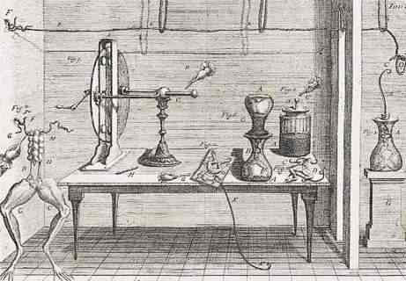

(Fig.1 an illustration of Galvani’s equipment.)

An accident occurred in the lab (as usual) where an assistant touched an exposed frog nerve with a metal scalpel, which caused a twitch in the frog’s muscles, which then led Galvani to believe in 2 things:

- There was some flow of charges across the nerve of this frog, which caused the twitching (which he called “animal electricity”).

- These charges were within the frog, specifically from its brain (when it was alive.)

Note: Alessandro Volta disagreed about the origin of the charges (specific for this experiment). He argued that they came from the electrode and not the frog itself, but this might be outside our scope.

From this point, we’ll be referring to this “signal” with its actual name: The action potential, or AP for short.

At that point, we only knew that there was electricity moving from the brain to muscles, which then caused them to twitch (somehow). That was uncharted ground for physiologists, who began to analyze different aspects of the action potential.

Emil du Bois-Reymond (1818–1896) ^{[2]} described the nerve signal as a “negative variation” in the
potential. He did this by using a very sensitive galvanometer connected to his arm. In a sense, he discovered the direction of the Action potential.

Then came Julius Bernstein ^{[3]} (1838–1917), who explained the signaling as an electro-chemical message caused by variations in ion concentration of intracellular and extracellular fluids (which are mainly sodium and potassium ions)

He also recorded a partial form of the AP. (only the hyperpolarization part.)
So now we know there’s a signal traveling through nerves, we know (roughly) what it looks
like, and that it occurs as a negative variation in the membrane potential.

Then we moved on to the second part of the process, which is modeling this signal.
(which we can see in Fig.2)

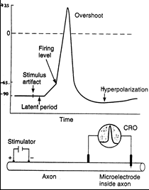
(Fig.2: action potential signal diagram)

Hodgkin & Huxley Model:
In 1952 Hodgkin & Huxley made one of the most important discoveries in neuroscience history. They used the squid giant axon (note that when we say squid giant axon, it means that the axon itself is large, not a giant squid, although a giant squid could have been useful).

The squid axon is so large that they could use microelectrodes to measure the Action Potential through it and determine its cycle (latent period - spike - polarization - depolarization).^{[4]} The shown figure represents the HH circuit that brought them the Nobel Prize in Physiology and Medicine in 1963.^{[5]}
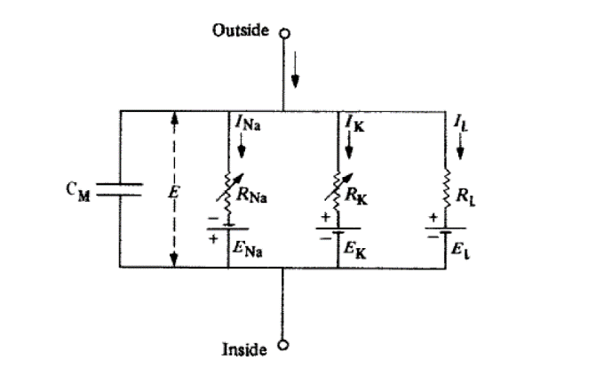
(Fig.3: HH Model)
Without digging deep into the HH model equations (which will be discussed later), The HH model represents the membrane potential difference between the inner and outer parts of the cell membrane.
Interestingly until 1940, There was no way to measure the membrane potential directly. All observations were on the extracellular activities, not the membrane itself. Cole Curtis' usage of the Wheatstone bridge in 1939 confirmed with clear evidence that Bernstein’s assumption in the early eighteenth century (that there is an increase in the membrane potential) is a fact. ^{[6]}
The first time to record the intracellular fluid was in 1945 using microelectrodes. The thickness of the giant axon of squid helped the two scientists not to damage the fiber. The period from 1947 to 1949 witnessed exceptional progress in experimenting with the squid giant axon. Hodgkin and Huxley managed to determine the voltage and then set the currents (due to the Ca++ ion pumps or due to Na+ ion pumps) directions and sources.
From 1949 until 1952, Hodgkin & Huxley succeeded in finding the correlation between the “Family of currents” which is the summation of the currents in the capacitor, K+ ions, Na+ ions, and the leakage currents.

I = C_{M}$\frac{dV}{dt}$ + g_{k}n⁴(V – V_{k}) + g_{Na}m³h(V – V_{Na}) + g₁(V – V₁)

Although Hodgkin & Huxley partnership ended here, their contribution to neuroscience did not end. For instance, In 1970, Neher and Sakmann managed to record the AP of single ion channels from even the smallest cells.^{[7]}

Fitzhugh-Nagumo Model:

After the publication of Hodgkin-Huxley’s equations (that represents the action potential as a 4-D dynamical system), Richard Fitzhugh (who was a scientist working at the biophysics Laboratory of the NIH (National Institutes of Health)) analyzed the mathematical properties of HH equations.
John Moore and FitzHugh started programming an analog computer to solve Hodgkin-Huxley equations. That was before the era of digital computers.

This analog computer plotted solutions of the HH equations. Its components are an operational amplifier, multipliers, function generators.

Although the physical basis of the HH equations describes the flow through the axon membrane of Na+ and K+ ions, phenomena of excitation above a specific value and propagation along the axon are not defined. So, Moore and FitzHugh found that simplifying the equations could isolate these properties from each other.

Dr. Kenneth Cole and Fitz-Hugh modified the Van der Pol equations for the nonlinear relaxation oscillator to simplify their equations that were similar to the equations describing the monostable multivibrator electronic circuit. Also, these equations are known as Fitzhugh-Nagumo equations, though they were called the "Bonhoeffer-Van der Pol model" by Fitzhugh.
Reprogramming the analog computer for these new equations was much easier as the equations were simpler. Only two multipliers and no function generators were needed.^{[8]}
The Heimburg-Jackson Model:
Although the Hodgkin-Huxley model describes the electrical aspects of action potentials, it doesn’t clarify some parameters (Ex. transient temperature and nerve volume variations).
So, in 2005, Heimburg and Jackson tried to address these aspects by adopting a thermodynamic framework.
From their point of view, the action potentials could be considered as intensity pulses (sound waves) spread along neuronal lipid membranes.
As a result of experimental observation, Heimburg and Jackson added a new term that describes dispersion to their equation.

Their model also implies the presence of an electrical pulse, a volume pulse, and a temperature pulse (heat release and absorption) as inseparable phenomena related to nerve excitation. They took into account that the change in the lateral density area (the packing of lipid molecules) alters the electric field across the membrane, increase/decrease in the length of hydrocarbon chains, and heat exchange with surroundings (Heimburg and Jackson 2005).

Mathematical modeling:

During this mathematical modeling we will go through the early first equations by Nernst (1899 - 1908) passing by HH model 1952 till we reach the recent updates by (Heimburg and Jackson 2005) of the PDEs representing action potential in mammalian neurons.

Let latter membrane be at position x = 0 ; call c the concentration of the salt, D its coefficient of diffusion. The process just explained is formalized as follows:
c_{t} = Dc_{xx} , c_{x}(0,t) = - $\frac{k}{D} i\left(t\right)$
c(x,0) = c₀ for 0 ≤ x $< ∞$

where i is the applied current density, k a proportionality constant.

Let v(x, t) = c(x, t) + x ^{k} i(t)
V_{t} – Dv_{xx} = x $\frac{k}{D} \frac{di}{dt}$ , V_{x} (0,t) = 0
V(x,0) = C₀ + x$\frac{k}{D} i(0)$ for 0 ≤ x $< ∞$

Now by defining the new function u such that:
u_{t} – Du_{xx} = f(x,t) =$\left\{\begin{aligned} x \frac{k}{D} \frac{di}{dt} x>0 \\ 0 x=0 \\ -x \frac{k}{D} \frac{di}{dt} x<0\end{aligned} \right.$(1)
u(x,0) = $ϕ$(x) = $\left\{\begin{aligned}C0+ x \frac{k}{D} i(0) x>0 \\ C0 x=0 \\ C0-x \frac{k}{D} i(0) x<0\end{aligned} \right.$(2)
Since u is even and the extension of v , then u_{x}(0; t) = 0 and u(x; t) = v(x; t) for x > 0. The solution for the inhomogeneous problem in u is:
$u\left(x,t\right)=\int_{-∞}^{∞}{ }S\left(x-y,t\right)ϕ\left(y\right)dy+ \int_{0}^{t}{ }\int_{-∞}^{∞}{ }S(x- y,t-s)f(y,s)dyds$ (3)
Where
$S(x,t)=\frac{1}{2\sqrt{πDt}}e^{-\frac{x^{2}}{4Dt}}$ (4)
is the diffusion kernel. Thus, $v$ is given by
$\begin{matrix}v(x,t)= & \int_{0}^{∞}{ } \left[S\left(x-y,t\right)+S\left(x+y,t\right)\right]\left[ϕ\left(y\right)\right]dy \\ & -\int_{0}^{ι}{ } \int_{0}^{∞}{ } \left[S\left(x-y,t-s\right)+S\left(x+y,t-s\right)\right]\left[-y\frac{k}{D}i^{'}(s)\right]dyds\end{matrix}$(5)

After substitution of $v$ into $v(x,t)=c(x,t)+x\frac{k}{D}i(t)$, the solution for $c$ is obtained:
$\begin{matrix}c\left(x,t\right)= & \int_{0}^{∞}{ } \left[S\left(x-y,t\right)+S\left(x+y,t\right)\right]\left[c_{0}+y\frac{k}{D}i\left(0\right)\right]dy \\ & -\int_{0}^{t}{ } \int_{0}^{∞}{ } \left[S\left(x-y,t-s\right)+S\left(x+y,t-s\right)\right]\left[-y\frac{k}{D}i^{'}\left(s\right)\right]dyds-x\frac{k}{D}i\left(t\right)\end{matrix}$
(6)
I.e.,
$$\begin{matrix}c(x,t)=\int_{0}^{∞}{ } \left[\frac{1}{2\sqrt{πDt}}e^{-\frac{(x-y)^{2}}{4Dt}}+\frac{1}{2\sqrt{πDt}}e^{-\frac{(x+y)^{2}}{4Dt}}\right]\left[c_{0}+y\frac{k}{D}i(0)\right]dy \\ -\int_{0}^{t}{ } \int_{0}^{∞}{ } \left[\frac{1}{2\sqrt{πD(t-s)}}e^{-\frac{(x-y)^{2}}{4D(t-s)}}+\frac{1}{2\sqrt{πD(t-s)}}e^{-\frac{(x+y)^{2}}{4D(t-s)}}\right]\left[-y\frac{k}{D}i^{'}(s)\right]dyds-x\frac{k}{D}i(t).\end{matrix}$$
(7)
Nernst reached in this way the conclusion that the strength-duration relation for the critical change of salt concentration in eliciting nerve excitation had to be of the form $\frac{I}{\sqrt{n}}=$ constant for alternating currents and $I\sqrt{t}=$ constant for constant currents.
$$\begin{matrix}c(x,t)=c_{0}+\int_{0}^{t}{ } \int_{0}^{∞}{ } & \left[\frac{1}{2\sqrt{πD(t-s)}}e^{-\frac{(x-y)^{2}}{4D(t-s)}}+\frac{1}{2\sqrt{πD(t-s)}}e^{-\frac{(x+y)^{2}}{4D(t-s)}}\right]* \\ & *\left[y\frac{k}{D}nIcos⁡nt\right]dyds-x\frac{k}{D}Isin⁡nt \end{matrix}$$
(8)
For constant currents, on the other hand, the explicit solution is
$$c\left(x,t\right)=c_{0}+\frac{k}{D}I\left[\frac{\sqrt{4Dt}}{\sqrt{π}}e^{-\frac{x^{2}}{4Dt}}+x\int_{-∞}^{x}{ } \frac{1}{2\sqrt{πDt}}e^{-\frac{z^{2}}{4Dt}}dz-x\int_{x}^{+∞}{ } \frac{1}{2\sqrt{πDt}}e^{-\frac{z^{2}}{4Dt}}dz\right]-x\frac{k}{D}I$$
(9)
By considering the concentration of salts at $x=0,(8)$ and (9) reduce respectively to
$c(0,t)=c_{0}+\frac{k}{D}\int_{0}^{t}{ }nIcos⁡ns\frac{\sqrt{4D(t-s)}}{\sqrt{π}}ds$
And
$c(0,t)=c_{0}+2kI\sqrt{\frac{t}{πD}}$ (10)
Now, the first solution gives, upon change of variables and integration,
$c(0,t)=c_{0}+\frac{I}{\sqrt{n}}\frac{2k}{\sqrt{πD}}\left[sin⁡nt\int_{0}^{\sqrt{nt}}{ } cos⁡\left(y^{2}\right)dy-cos⁡nt\int_{0}^{\sqrt{nt}}{ } sin⁡\left(y^{2}\right)dy\right]$ (11)
For sufficiently long timescales, the two integrals in the square brackets can then be approximated by the limit value $\frac{\sqrt{2π}}{4}$ so to give
$c(0,t)=c_{0}+\frac{I}{\sqrt{n}}\frac{k}{2\sqrt{D}}\left(sin⁡nt-\frac{π}{4}\right)$ (12)
Nernst reached in this way the conclusion that the strength-duration relation for the critical change of salt concentration in eliciting nerve excitation had to be of the form $\frac{I}{\sqrt{n}}=$ constant for alternating currents and $I\sqrt{t}=$ constant for constant currents.
Lapicque (1907-1926)

(Fig. 4 Lapicque model circuit)

This circuit (seen in Fig.4) is composed of a resistance R, representing the sum of the resistances in the stimulating circuit.
A capacitor K, representing the capacitance of the nerve membrane.
A resistance $ρ$, representing the leakage resistance of the portions of membrane in contact with the cathode.
$$Kdv=\frac{V-v}{R}dt-\frac{v}{ρ}dt$$
$-\frac{R+ρ}{KRρ}dt=\frac{dv}{v-\frac{Vρ}{R+ρ}}$ (13)
Which has general solution
$C-t\frac{R+ρ}{KRρ}=log⁡\left(\frac{Vρ}{R+ρ}-v\right)$ (14)
Under initial condition v(0)=0
$e^{-t\frac{R+ρ}{KRρ}}=1-\frac{R+ρ}{Vρ}v$ (15)
Strength of applied voltage is represented as V
$$V=v\frac{R+ρ}{R}\frac{1}{1-exp⁡\left(-t\frac{RρK}{R+ρ}\right)}$$
$V=\frac{α}{1-e^{-\frac{t}{β}}}$ (16)

Blair (1932)
Variable $p$ is referred to as the “state of excitation”
$\frac{dp}{dt}=KV-kp$ (17)
K and k are constants.
$\int_{0}^{h+αV}{ }\frac{kdp}{KV-kp}=-k\int_{0}^{t}{ }dt$

$log⁡\frac{KV}{KV-k(\overline{h}+αV)}=k$ (18)
this equation (18) can be written as
$$log⁡\frac{KV}{(K-αk)V-(K-kα)R}=kt$$
$log⁡\frac{CV}{V-R}=kt$ (19)
Where
$$C=\frac{K}{K-kα} (20)$$
According to Lapicque, we consider equation (21) to obtain the explicit expression
$\begin{aligned}C\frac{dv}{dt}&=\frac{V-v}{R}-\frac{v}{ρ} \\ &=\frac{V}{R}-v\left(\frac{1}{R}+\frac{1}{ρ}\right) \\ &=\frac{V}{R}-v\frac{ρ+R}{Rρ}\end{aligned}$ (21)
Which is Blair’s equation (17) with K=$\frac{1}{R}$ and k=$\frac{ρ+R}{RCρ}$

Hill (1936)
V and U , respectively referred to as "local potential" and threshold. here I is the externally injected current, while b , β , λ and k are constants with λ and k satisfying λ >> k
$\begin{aligned}\frac{dV}{dt}&=bI-\frac{V-V_{0}}{k} \\ \frac{dU}{dt}&=\frac{V-V_{0}}{λ}-\frac{U-U_{0}}{β}\end{aligned}$ (22)
Hill assumed the condition β = λ to hold. In the most general case then, admitting any form of current, the solution was given by:
$\begin{aligned}V=V_{0}+be^{-\frac{t}{k}}\int_{θ=0}^{θ=t}{ }Ie^{\frac{θ}{k}}dθ \\ U=U_{0}+\frac{e^{-\frac{t}{λ}}}{λ}\int_{θ=0}^{θ=t}{ }\left(V-V_{0}\right)e^{\frac{θ}{λ}}dθ\end{aligned}$(23)
In the case of constant current, The above equation is then solved as follows.
$$\begin{aligned}V=V_{0}+bkI\left(1-e^{-\frac{t}{k}}\right) \\ U=U_{0}+bkI\left[1+\frac{e^{-\frac{t}{k}}}{\frac{λ}{k}-1}-\frac{e^{-\frac{t}{λ}}}{1-\frac{k}{λ}}\right] (24)\end{aligned}$$
The condition of excitation (U=V) then translates into
$$V_{0}+bkI\left(1-e^{-\frac{t}{k}}\right)=U_{0}+bkI\left[1+\frac{e^{-\frac{t}{k}}}{\frac{λ}{k}-1}-\frac{e^{-\frac{t}{λ}}}{1-\frac{k}{λ}}\right]$$
$\begin{aligned}\frac{V_{0}-U_{0}}{bk}=I\left[e^{-\frac{t}{k}}+\frac{ke^{-\frac{t}{k}}}{λ-k}-\frac{λe^{-\frac{t}{λ}}}{λ-k}\right] \\ =I\frac{λ}{λ-k}\left(e^{-\frac{t}{k}}-e^{-\frac{t}{λ}}\right)\end{aligned}$ (25)
After rearrangement:
$$I=\frac{λ-k}{λbk}\frac{V_{0}-U_{0}}{e^{-\frac{t}{k}}-e^{-\frac{t}{λ}}}$$
by imposing V = U0 at t = ∞ In the above eq. This giving bkI0 = U0 −V0, substitution into the above led to:
$I=\frac{I_{0}\left(1-\frac{k}{λ}\right)}{e^{-\frac{t}{λ}}-e^{-\frac{t}{k}}}$ (26)
If we apply the condition λ >> k to this eq, we get the following:
$I=\frac{I_{0}}{1-e^{-\frac{t}{k}}}$ (27)
Anode excitation: after exposure of the nerve to an externally applied constant current over a duration ̄t leads to
$$\begin{aligned}V=V_{0}-bkI\left(1-e^{-\frac{t}{k}}\right)+bkI\left(1-e^{-\frac{t- ̄t}{k}}\right)=V_{0}-bkI\left(e^{-\frac{t- ̄t}{k}}-e^{-\frac{t}{k}}\right) \\ U=U_{0}-bkI\left[1+\frac{e^{-\frac{t}{k}}}{\frac{λ}{k}-1}-\frac{e^{-\frac{t}{λ}}}{1-\frac{k}{λ}}\right]+bkI\left[1+\frac{e^{-\frac{t-\overline{t}}{k}}}{\frac{λ}{k}-1}-\frac{e^{-\frac{t- ̄t}{λ}}}{1-\frac{k}{λ}}\right] \\ =U_{0}-bkI\left[\frac{e^{-\frac{t-\overline{t}}{λ}}-e^{-\frac{t}{λ}}}{1-\frac{k}{λ}}-\frac{e^{-\frac{t-\overline{t}}{k}}-e^{-\frac{t}{k}}}{\frac{λ}{k}-1}\right]\end{aligned}$$
(28)
Anode excitation then occurs when (V=U)
$$V_{0}-bkI\left(e^{-\frac{t-\overline{t}}{k}}-e^{-\frac{t}{k}}\right)=U_{0}-bkI\left[\frac{e^{-\frac{t-\overline{t}}{λ}}-e^{-\frac{t}{λ}}}{1-\frac{k}{λ}}-\frac{e^{-\frac{t-\overline{t}}{k}}-e^{-\frac{t}{k}}}{\frac{λ}{k}-1}\right] (29)$$
When
$$\begin{aligned}U_{0}-V_{0}=bkI\frac{λ}{λ-k}\left[e^{-\frac{t-\overline{t}}{k}}-e^{-\frac{t}{k}}-e^{-\frac{t-\overline{t}}{λ}}+e^{-\frac{t}{λ}}\right] \\ (30)\end{aligned}$$
Or
$$I=\frac{U_{0}-V_{0}}{bk}\frac{\left(1-\frac{k}{λ}\right)}{e^{-\frac{t-t}{k}}-e^{-\frac{t}{k}}-e^{-\frac{t-\overline{t}}{λ}}+e^{-\frac{t}{λ}}}$$
(31)

The Hodgkin-Huxley Model (1952)
(Fig.5: HH Model)

$I=Cₘ \frac{dV}{dt}+Ii$ (32)
Where:
I is the total membrane current (inward current positive)
I_{i} is current density carried by ions (inward current positive)
V is the membrane potential (depolarization negative)
C_{m} is the membrane capacitance (assumed constant)
t is time
Using Ohm’s law I = g*V, where g is the conductance, the three currents I_{Na}, I_{K} and I_{leak} can be expressed:
I_{Na} = g_{Na} (V - E_{Na})

I_{K} = g_{K} (V - E_{K})

I_{leak} = g_{leak} (V - E_{leak})

The potassium conductance:

Variation of the potassium conductance g_{K} measured after establishing abruptly a transmembrane voltage equal to the numbers on the right

(Fig.6 K conductance with diff. voltages.)
g_{k} = g⎺_{k} n⁴

$\frac{dn}{dt}= α$_{n} (1-n) – $β$_{n}n (33)
Where:
g⎺_{k} is a constant representing the maximum potassium conductance, $α$_{n} and $β$_{n} are voltage dependent time-independent rate constants, while n is a scalar variable $∈$ [0, 1].

In order to permit the comparison with the experimental data, the expression for the potassium conductance was written in the form:

g_{k} = {${(gK∞)}^{\frac{1}{4}}$ – [${(gK∞)}^{\frac{1}{4}}- {(gKo)}^{\frac{1}{4}}$ ]$e^{-\frac{t}{τn}}$}⁴

^{Where:}
^{gK}$∞$ and gKo are respectively the value that gK has after the voltage step and at time t = 0

The sodium conductance

For the derivation of the sodium conductance the following equations were used:
g_{Na} = m³hg⎺_{Na}

$\frac{dm}{dt}$= $α$_{m} (1 - m) – $β$_{m}m

$\frac{dh}{dt}$= $α$_{h} (1 - h) – $β$_{h}h

Variation of the sodium conductance g_{Na} measured after establishing abruptly a transmembrane voltage equal to the numbers on the left.
(Fig.7 Na conductance with diff. voltages.)
The deduction of $α$’s and $β$’s expressions follow from the same reasoning used for the potassium rate constants, with the only difference that now there are two first order differential equations rather than only one.

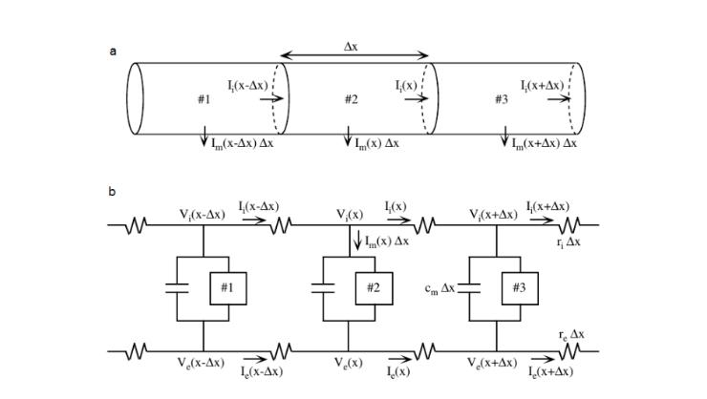
It is now possible to write the equations that give the time and voltage dependencies of the transmembrane current density of a nerve fiber:

(Fig. 8 Neuron model according to HH.)
I = C_{M} $\frac{dV}{dt}$ + $\overset{‾}{g}$_{K} n⁴(V - E_{K}) +m³h$\overset{‾}{g}$_{Na}(V – E_{Na}) + g⎺_{leak} (V – V_{leak}) (34)

The neuron is divided longitudinally in subsections (patches) of length ∆x
Vi(x) and Ve(x) represent respectively the potentials inside and outside the cell at position x
Im(x) stands for the membrane current per unit length. Ii(x) and Ie(x) , ri(x) and re(x) are the longitudinal internal and external currents and resistances (per unit length).
From Ohm's law one has
$V_{i}(x)-V_{i}(x+Δx)=I_{i}(x)r_{i}Δx , V_{e}(x)-V_{e}(x+Δx)=I_{e}(x)r_{e}Δx$ (35)
which give, by taking the limit for $Δx→0$,
$$\lim_{Δx→0} \frac{V_{i}\left(x\right)-V_{i}\left(x+Δx\right)}{Δx}=\frac{∂V_{i}}{∂x}=-r_{i}I_{i}\left(x\right) ,$$
$$\frac{∂V_{e}}{∂x}=-r_{e}I_{e}\left(x\right) (36)$$
At the same time, the conservation of currents at intracellular and extracellular nodes gives
$$I_{i}(x-Δx)-I_{i}(x)=I_{m}(x)Δx , I_{e}(x-Δx)-I_{e}(x)=-I_{m}(x)Δx$$
meaning, for $Δx→0$, respectively
$$\frac{∂I_{i}}{∂x}=-I_{m}(x) , \frac{∂I_{e}}{∂x}=I_{m}(x)$$
By differentiating equations (36), it is obtained that
$$\frac{∂^{2}V}{∂x^{2}}=\frac{∂^{2}\left(V_{i}-V_{e}\right)}{∂x^{2}}=-r_{i}\frac{∂I_{i}}{∂x}+r_{e}\frac{∂I_{e}}{∂x}=\left(r_{i}+r_{e}\right)I_{m}$$
implying, from equation (34),
$I_{m}=c_{m}\frac{∂V}{∂t}+{\overset{‾}{g}}_{K}n^{4}\left(V-E_{K}\right)+{\overset{‾}{g}}_{Na}m^{3}h\left(V-E_{Na}\right)+{\overset{‾}{g}}_{l}\left(V-V_{l}\right)$ (36)
where constants and variables are as defined previously. The following equation is then obtained:
$\frac{1}{\left(r_{i}+r_{e}\right)}\frac{∂^{2}V}{∂x^{2}}=c_{m}\frac{∂V}{∂t}+{\overset{‾}{g}}_{K}n^{4}\left(V-E_{K}\right)+{\overset{‾}{g}}_{Na}m^{3}h\left(V-E_{Na}\right)+{\overset{‾}{g}}_{l}\left(V-V_{l}\right)$(37)
which is the cable equation specific for the Hodgkin-Huxley model.
The two physiologists assumed the squid giant axon to be surrounded by a large volume of conducting fluid $^{12}$, which implies $r_{e}$ to be negligible compared to $r_{i}$, thus
$\frac{1}{\left(r_{i}+r_{e}\right)}=\frac{1}{r_{i}}=\frac{a}{2R_{i}}$ (38)
where $a$ is the radius of the nerve and $R_{i}$ the specific resistance of the axonal intracellular space. Substituting eq (38) into (37), one obtains
$\frac{a}{2R_{i}}\frac{∂^{2}V}{∂x^{2}}=C_{M}\frac{dV}{dt}+{\overset{‾}{y}}_{K}n^{4}\left(V-E_{K}\right)+{\overset{‾}{y}}_{Na}m^{3}h\left(V-E_{Na}\right)+{\overset{‾}{y}}_{l}\left(V-V_{l}\right)$ (39)
Although this equation is not solvable as it is, experimental evidence suggests that one can impose the constraint that the action potential travels at constant velocity $θ$, and that its shape is maintained unaltered during the propagation. Substituting the travelling wave ansatz
$V(x,t)=\overset{ˆ}{V}(x-θt)$ (40)
gives
$$\frac{a}{2R_{2}θ^{2}}\frac{d^{2}V}{dt^{2}}=C_{M}\frac{dV}{dt}+{\overset{‾}{g}}_{K}n^{4}\left(V-E_{K}\right)+{\overset{‾}{g}}_{Na}m^{3}h\left(V-E_{Na}\right)+{\overset{‾}{g}}_{l}\left(V-V_{l}\right)$$
(41)
$\begin{matrix}\frac{dn}{dt} & =α_{n}(1-n)-β_{n}n \\ \frac{dm}{dt} & =α_{m}(1-m)-β_{m}m \\ \frac{dh}{dt} & =α_{h}(1-h)-β_{h}h\end{matrix}$ (42)
Equations (41),(42) are often referred to as the complete Hodgkin-Huxley equations for the propagating action potential.
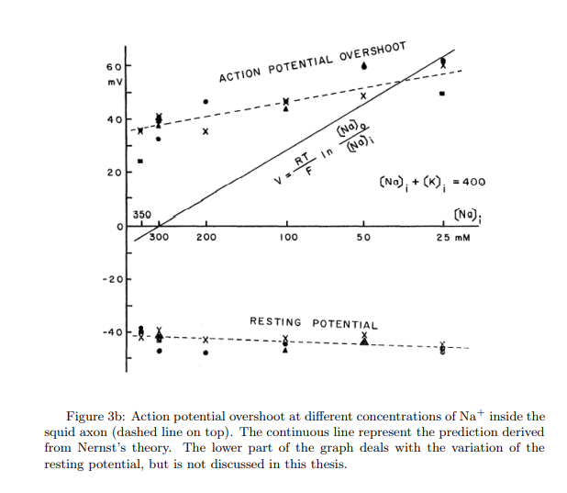
(Fig.9 Relation between action potential overshoot and sodium concentrations.)
The FitzHugh-Nagumo model (1961)
The Hodgkin-Huxley equations for the action potential represent a four-dimensional dynamical system which, isn’t easy to handle theoretically. FitzHugh proposed a simplification of the original model consisting of a two-dimensional system.
Recalling the equations describing the dynamics of the gating variables in the Hodgkin-Huxley model, but the gating variables n and h have a much slower kinetics than m14, and the model retains its characteristic features even if h is set constant:
$$\frac{dn}{dt}=α_{n}\left(1-n\right)-β_{n}n$$
$$\frac{dm}{dt}=α_{m}\left(1-m\right)-β_{m}m$$
$\frac{dh}{dt}=α_{h}\left(1-h\right)-β_{h}h$ (43)
the first one of these could be rewritten in the form:
$τ\frac{dn}{dt}=n_{∞}-n$ (44)
Where $n_{∞}=\frac{α_{n}}{α_{n}+β_{n}}$ and $τ=\frac{1}{α_{n}+β_{n}}$
Moreover, the variables m and h could be replaced in the Hodgkin-Huxley equation (36)
respectively by the limit value ${m^{3}}_{∞}$, and by the constant $h_{0}$. In this way, the
following two-dimensional system is obtained:
$\frac{dV}{dt}=-{\overline{g}}_{K}n^{4}\left(V-V_{K}\right)+{\overline{g}}_{Na}{m^{3}}_{∞}h\left(V-V_{Na}\right)+{\overline{g}}_{l}\left(V-V_{l}\right)+I_{appl}$ (45)
The general form of the two-dimensional system FitzHugh and Nagumo:
$\frac{dv}{dt}=v\left(v-a\right)\left(1-v\right)-ω+l$ (46)
$\frac{dw}{dt}=βv-γω$ (47)

The Heimburg-Jackson model (2005)
As we mentioned in the literature review, the Hodgkin-Huxley model describes the electrical aspects of action potentials. Heimburg and Jackson tried to address these aspects by adopting a thermodynamic framework. From their point of view, the action potentials could be considered as sound waves spreading along neuronal lipid membranes. Restricting the problem to one dimension, using the equation for the propagation of sound-waves in compressible media :
$\frac{∂^{2}}{{∂t}^{2}}∆ρ^{A}=\frac{∂}{∂x}(c^{2}\frac{∂}{∂x}∆ρ^{A})$ (48)
Where: $∆ρ^{A}=ρ^{A}-ρ_{0}^{A}$
($ρ^{A}$ and $ρ_{0}^{A}$ the instantaneous and equilibrium lateral densities)
$$C=\frac{1}{\sqrt{{ρ^{A}K}_{s}^{A}}}$$
(c is the velocity and the isentropic lateral compressibility of the membrane)
From the experimental observation of frequency dependence of the velocity of sound in two-dimensional artificial membranes i.e. dispersion, Heimburg and Jackson added to the right hand side of equation (49), the arbitrarily chosen dispersive term:
$-h\frac{∂^{4}}{{∂x}^{4}}∆ρ^{A}$ (49)

where (h > 0), and $c^{2}$ in equation (49) can be approximated by using its Taylor expansion in $ρ^{A}$.
So, the Heimburg-Jackson wave equation for nerve excitation ^{[4]}:
eq.(50)

The Solution of Heimburg equation:
The function of the nerve has been attributed to the electrical pulse propagation along the nerve fibre and is described by the widely accepted Hodgkin-Huxley (HH) model that’s actually based on the telegraph equation where the inductivity is neglected. Although this model is able to describe several important and experimentally tested properties , like a typical asymmetric pulse with an overshoot, the existence of a threshold for an excitation for triggering the pulse (the all-or-none phenomenon),
There is a number of phenomena which is not described by this model. By the experiments Iwasa et al and Tasaki noticed by their experiments that the propagation of the nerve pulse is accompanied by the mechanical swelling of the nerve fibre and with reversible heat exchange. Which means that there is a mechanical wave associated with the nerve pulse. Lately the effect was demonstrated the neuron of the lobster.
To avoid this problem, Heimburg and Jackson (HJ) have suggested a Boussinesq-type equation describing a nonlinear wave propagation along the cylindrical bio membrane. Their model is based on regular wave equation where velocity c is determined by
where c₀ is the velocity of low amplitude sound and p and q are determined from the experiments,
and is the change of density. Also, a fourth order ad hoc dispersive.
term (-hu_{xxxx}) was added to calculate dispersion. Which gives this equation

$$u_{tt}={\left[\left(c_{0}^{2}+pu+qu^{2}\right)u_{x}\right]}_{x}$$
$-hu_{xxxx}$(52)
Engelbrecht et al recently enhanced this model. from the point of view of solid mechanics. It is known that the presence of fourth order spatial derivatives can lead to instabilities and infinite propagation velocities for higher harmonics in the case of anomalous dispersion. To avoid this, they added a new term of fourth order mixed derivative into Eq. (52) .so this new term calculates for inertia of the microstructure.
The modified HJ model gives
$$u_{tt}={\left[\left(c_{0}^{2}+pu+qu^{2}\right)u_{x}\right]}_{x}-h{1u}_{xxxx}+h2u_{xxtt}$$
(53)
where h₁ = h and h₂ is a new dispersion constant.
The nonlinearity in the terms of plain u is uncommon in Boussinesq-type equations but mathematically nothing can prevent it, we can notice that the nonlinearity can be achieved with Lagrangian formalism by using nonlinear terms containing $u·u_{x}^{2}$ and $u^{2}·u_{x}^{2}$ with coefficients p and q, respectively in the expression for potential energy.
We note that the parameters used in these equations were taken from a wide possible range and not derived from a certain experiment. Which allows us to explain an interesting and rich behaviour of solutions of Eq. (53)

Mathematical Solution:
The dimensionless form of Eq. (53) is
$$U_{TT}=\left(1+PU+QU^{2}\right)U_{XX}+(P+2QU)U_{X}^{2}-H_{1}U_{XXXX}+H_{2}U_{XXTT},$$
(54)
Where:
$X=x/l,T=c_{0}t/l,U=u/ρ_{0}$
$P=pρ_{0}/c_{0}^{2},Q=qρ_{0}^{2}/c_{0}^{2},H_{1}=h_{1}/\left(c_{0}^{2}l^{2}\right)$
$H_{2}=h_{2}/l^{2}.$
$l$ is a certain length and $ρ_{0}$ is the lateral equilibrium density.
The analytical solution of Eq. (54) is
$$u(ξ)=\frac{6\left(β^{2}-1\right)}{P\left(1+\sqrt{1+6Q\left(β^{2}-1\right)/P^{2}}cosh⁡\left(ξ\sqrt{\left(1-β^{2}\right)/\left(H_{1}-H_{2}β^{2}\right)}\right.\right.},$$
Eq. (55)
where $ξ=X-βT$ and $β$ is the velocity of the solitary wave.
We also note that if H₂=0 the Eq. (55) reduces to the solution of Eq. (52).
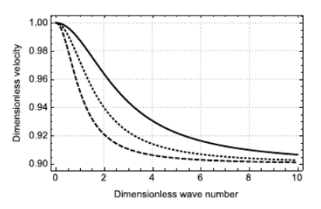
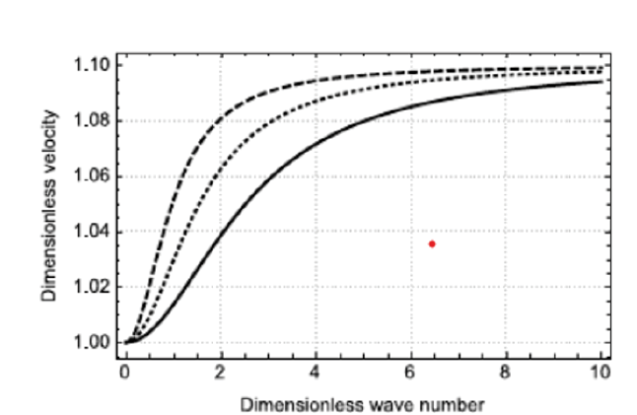

(Fig. 10 Dispersion curves for Eq. (54) in case of normal (first graph) and anomalous dispersion (second graph).)
First ﬁgure: H₁= 0.81 and H₂= 1 (dashed line),
H₁= 0.32 and H₂= 0.4(dotted line), H₁= 0.81 and
H₂= 0.1(solid line).
Second ﬁgure: H₁= 1.21 and H₂= 1 (dashed line),
H₁= 0.48 and H₂= 0.44 (dotted line), H₁= 0.18 and H₂= 0.15 (solid line).
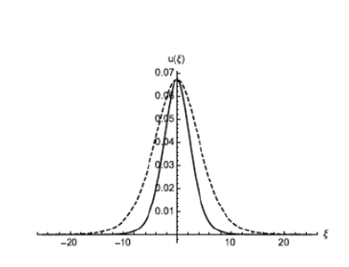
(Fig. 11 Solution profile 1.)
Soliton proﬁles for P=−16.6, Q= 79.5, H₁= 2 and H₂= 1.9 β= 0.83 (see fig. 11)

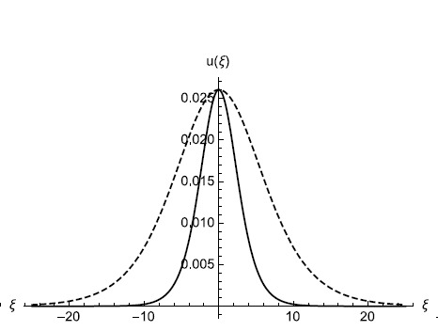
(Fig. 12 Solution profile 2)
Fig. 12 represents the same profile as Fig. 11 but with β= 0.93
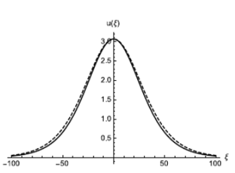
(Fig. 13 Solution profile 3)
In this profile, P=−0.21, Q= 0.0043, H₁= 72.14, H₂=10 and β= 0.89.
Solid lines represent a solution for Eq. (52) and dashed lines - for Eq. (53).
The dispersion type depends on the ratio of the dispersion constants:
if H₁/H₂<1 then dispersion type is normal.
if H₁/H₂>1 then we have anomalous dispersion.
- The asymptotic velocity in both cases is equal to c₁=(H₁/H₂ )^{(-1/2)}.
- When H₁=H₂ then there is no dispersion and all the harmonics travel at same velocity.
- The effect of the dispersion parameter H₂ on the analytical solution is demonstrated in Figure(11,12,13) where in case of anomalous dispersion H₂ has a clear effect on the soliton width.
Numerical Solutions:
By using Discrete Fourier Transform (DFT)^{[9]} based pseudo-spectral method (PSM) to solve equation (58) until we reach the following equation:
$φ=U-H_{2}U_{XX},U=φ^{-1}\left[\frac{F(φ)}{1+H_{2}k^{2}}\right],\frac{∂^{m}U}{∂X^{m}}=F^{-1}\left[\frac{(ik)^{m}F(φ)}{1+H_{2}k^{2}}\right]$ (56)
In expressions (56) F inverse denotes the inverse Fourier transform and F - the Fourier transform. Equation (54) is now rewritten in terms of the variable $φ$ as:
$φ_{TT}=\left(1+PU+QU^{2}\right)U_{XX}+\left(P+2QU\right){\left(U_{X}\right)}^{2}-H_{1}U_{XXXX}$ eq.(57)
This equation can be easily solved by making use of the PSM after reducing it to a system of two first-order differential equations.^{[9]}
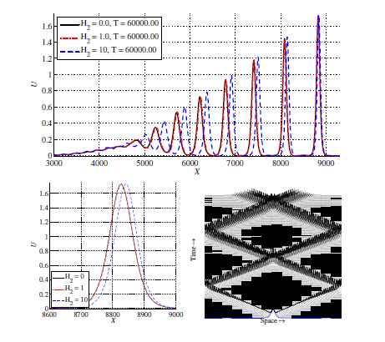

(Figure 14: Wave profiles for P = -0.21,
Q = 0:0043, H1 = 72:14 and H2 = 10)
A bell-shaped pulse U (X, 0) = A₀*sech² (B₀*X) is used as an initial condition. Initial velocity of the pulse is taken to be zero in which case the pulse splits into two bell-shaped pulses with half of the initial amplitude and propagating in opposite directions. Further on we take B₀ = 1/512 (the width parameter of the sech²-type initial pulse), A₀ = 2 (the amplitude of the initial pulse) and the spatial length is 8192π. The number of grid points in space is n = 2¹².
The governing equations are solved^{[9]}, and results presented in the dimensionless form. Periodical boundary conditions are used.
Results:
The numerical solution of Eq. (57) is plotted in Figure 14 where it can be seen that the train of solutions will emerge in case of chosen parameters in case of the initial sech2-type pulse. Three types of solutions are represented in Figure 3: H2 = 0 which corresponds to the original HJ model (1), H2 = 1:0 and H2 = 10. It can be seen that in case of H2 = 10 the solitary train travels slightly faster than in case of H2 = 1:0 or H2 = 0. The effect is quite subtle for the main pulse (see Figure 3 middle plot) and relatively large for the smaller amplitude pulses. In fact, it appears from Figure 3 that the speed increases linearly with the decreasing amplitude.
Summary for Mathematical solution:
The improved HJ model was introduced by Engelbrecht et al. from the viewpoint of solid mechanics. Dispersion analysis has shown that addition of fourth order mixed derivatives will make the propagation speed finite for all the harmonics which is crucial for the physically sound model. Here we have shown additional advantages of the dispersion parameter H2. Most importantly the additional dispersion parameter can be used in order to get more localized pulses at all propagation speeds. As noted in earlier publications the true meaning of all the dispersion parameters is still an open question, which has to be answered. Numerical modelling described above gives more information about the process and may help to clarify the role of first principles for deriving the governing equations for bio-membranes.

Scenarios:
Ions flowing through the plasma membrane channels are essential for the generation and propagation of the action potentials thus any change/deformation/mutation in any of these channels will probably lead to a specific disease as hypokalemic periodic paralysis, myotonias, long QT syndrome, Brugada syndrome, malignant hyperthermia and myasthenia and other Neuronal disorders, e.g., epilepsy, episodic ataxia, familial hemiplegic migraine, Lambert-Eaton myasthenic syndrome, Alzheimer’s disease related to the type of this change, This change maybe be a change in sodium, potassium, or calcium concentration either by an increase or a decrease in its amount.
Scenario1:
Hypokalemic periodic paralysis
(Physiology):
In this case there is a mutation which either occur in CACNA1S (gene provides instructions for making the main piece (subunit) of a structure called a calcium channel) and it’s called 1-type or SCN4A genes (gene belongs to a family of genes that provide instructions for making sodium channels) and it’s called 2-type.
Calcium channels made by CACNA1S are located in the outer membrane of muscle cells, so they can transmit action potential from the cell surface to inside the cell , while sodium channels transport positively charged sodium atoms (sodium ions) into cells, play a key role in a cell’s ability to generate and transmit action potential thus these mutations are a loss of function, such that the channels cannot open normally therefore the channel has a reduced excitability and signals from the central nervous system are unable to depolarise the muscle as AP doesn’t reach the firing level due to slow inflow of sodium ions. The mutations in these genes also change the way the protein channels work as a result the concentration of the potassium decreases and this low extracellular potassium ion concentration will cause the muscle to repolarise to the resting potential more quickly and even if calcium conductance does occur it cannot be sustained. It becomes more difficult to reach the calcium threshold at which the muscle can contract, this will cause muscle to not contract and will cause muscle weakness and paralysis.
Analysis of Scenario 1:
α & β values will change so the flow of sodium ions decreases, and the sodium conductance decreases thus current induced by sodium ions (Na+) is reduced so the total membrane current decreases and the membrane potential does not reach the firing level leading to no muscle contraction (due to no AP) and eventually, weakness and paralysis of the muscle.
Since αm, βm, αh, βh values will be disrupted, then the values of m, h and τ will decrease:
m$∞$ = $α$_{m}/($α$_{m +} $β$_{m}) , $τ$_{m} = 1/($α$_{m +} $β$_{m})

h$∞$ = $α$_{h}/($α$_{h +} $β$_{h}) , $τ$_{h} = 1/($α$_{h +} $β$_{h}) (58)

so, we conclude that the sodium conductance decreases:
g_{Na} = $\overline{g}$_{Na} * m³$∞$ * h₀ [1-exp(-t/$τ$_{m})]³ exp(-t/$τ$_{h})
(59)
thus, the current induced by the sodium ions will decrease:
I_{Na} = g_{Na}(V – E_{Na}) (60)
Leading to the decrease in the total membrane current:
$I=Cₘ \frac{dV}{dt}$ + I_{Na} + I_{K} + I_{Leak} (61)
Scenario 2:
Brugada Syndrome:

Brugada syndrome (BrS) is a rare, but potentially life-threatening heart rhythm genetic disorder in which the electrical activity within the heart is abnormal. Those affected may have episodes of passing out. The abnormal heart rhythms that are seen in those with Brugada syndrome often occur at rest. They may be triggered by a fever.

The heart doesn't pump enough blood to the rest of your body. So, you can faint if the abnormal rhythm lasts for a short time. Sudden cardiac death can occur if the abnormal heartbeat doesn't stop. This sudden loss of heart function, breathing, and consciousness often occurs while sleeping.

Mutations in the SCN5A cardiac voltage-gated sodium channel can be responsible for the syndrome. It’s characterized by prolonged recovery from inactivation and shift of steady-state activation and inactivation to more negative potentials. This can increase inward sodium current during the action potential upstroke.

The main aim when treating people with Brugada syndrome is to reduce the risk of sudden death due to serious abnormal heart rhythms such as ventricular fibrillation or polymorphic ventricular tachycardia. The treatments also include preventive measures such as avoiding aggravating medications and reducing fever. While some people with this condition are at high risk of serious heart rhythm disturbances, others are at much lower risk, meaning that some may require more intensive treatment than others.
Analysis of Scenario 2:
Due to high affinity to inflow of sodium, activation rate ($α$) increases
$α$_{m} = 0.1(V+25)/(exp $\frac{V+25}{10}$ -1)
$α$_{h} = 0.07 exp(V/20) (62)
So by increasing of activation rate, (m, h, $τ$_{m,} $τ$_{m)} increases
m$∞$ = $α$_{m}/($α$_{m +} $β$_{m}) , $τ$_{m} = 1/($α$_{m +} $β$_{m})

h$∞$ = $α$_{h}/($α$_{h +} $β$_{h}) , $τ$_{h} = 1/($α$_{h +} $β$_{h}) (63)

And the conductance of the sodium channel increases
g_{Na} = $\overline{g}$_{Na} * m³$∞$ * h₀ [1-exp(-t/$τ$_{m})]³ exp(-t/$τ$_{h})
(64)

thus, the current induced by the sodium ions will increase
I_{Na} = g_{Na}(V – E_{Na}) (65)
Leading to the increase in the total membrane current
$I=Cₘ \frac{dV}{dt}$ + I_{Na} + I_{K} + I_{Leak} (66)
So, the heartrate increases leading to sudden loss of heart function, breathing and consciousness.
Scenario 3:
Long QT Syndrome:
The long QT syndrome (LQTS)^{[10]} is a disorder characterized by a prolonged cardiac action potential. This delay in cellular repolarization can cause sudden, uncontrollable, dangerous arrhythmias in response to exercise or stress. Arrhythmias are problems related to the rate or rhythm of the heartbeat.
People who have LQTS also can have arrhythmias for no known reason. However, not everyone who has LQTS has dangerous heart rhythms and can be fatal.
The timing of the heart's electrical activity is complex, and the body carefully controls it. Normally the QT interval is about a third of each heartbeat cycle. However, people who have LQTS, the QT interval lasts longer than normal.
One form of LQTS has been linked to the human cardiac voltage-gated sodium channel gene (SCN5A).
Three distinct mutations have been identified in the sodium channel gene. The biophysical and functional characteristics of each of these mutant channels were determined by mutations of a recombinant human heart sodium channel. Each mutation caused a sustained, non-inactivating sodium current amounting to a few percent of the peak inward sodium current, observable during long (>50 msec) depolarizations. The voltage dependence and rate of inactivation were altered, and the rate of recovery from inactivation was changed. These mutations in diverse regions produce a common defect in channel gating that can cause the long QT phenotype. The sustained inward current caused by these mutations will prolong the action potential. Furthermore, they may create conditions that promote arrhythmias due to prolonged depolarization and the altered recovery from inactivation. These results provide insights for successful intervention in the disease.

Analysis of Scenario 3:

At types (LQTS 1&2), The voltage dependence and rate of inactivation ($β$_{n}) of potassium ions (K⁺) channels were altered (decreased)
$β$_{n} = 0.125 exp(V/80) (67)

So, the time ($τ$) of the action potential will increase

$τ= \frac{1}{αn+ βn}$ (68)

At type (LQTS 3), The voltage dependence and rate of inactivation ($β$_{n}) of sodium ions (Na⁺) channels were altered (decrease)
$β$_{m} = 4 exp(V/18) (69)

$β$_{h} = 1/(exp $\frac{V+30}{10}$ +1) (70)

So, the time ($τ$) of the action potential will increase

$τ$_{m} = 1/($α$_{m +} $β$_{m})

$τ$_{h} = 1/($α$_{h +} $β$_{h}) (71)

Conclusion:

In this project, we talked about the action potential, describing its discovery by Luigi Galvani, and how it was measured and modeled.
Firstly, we talked about Hodgkin & Huxley model that considered the action potential as an electrical current induced by inflow and outflow of ions through channels.
Then we talked about Heimberg & Jackson model. Heimberg managed to describe the wave equation that HH model reached from the viewpoint of solid mechanics. He focused on the dispersion constant to get the relation between dimensionless wave number and dimensionless velocity.
In Fitzhugh - Nagumo model, the action potential was considered a sound signal of two dimensions.
Eventually, we introduced some problems that occur when a parameter of action potential is defected, the solutions to them and how they are analyzed using these models.

Future work:

We would like to point out that the findings in this report are not exactly suggesting a specific cure for the disease, it’s just explaining the mechanisms behind some of them, a lot of ground needs to be covered in terms of clinical trials to find a cure that addresses the issues pointed out by the methodology.

References:
[1] M. Piccolino,”Luigi Galvani and animal electricity: two centuries after the foundation of electrophysiology”,Trends in Neurosciences,
Volume 20, Issue 10,1997,Pages 443-448
https://www.sciencedirect.com/science/article/pii/S1631069106000370?via%3Dihub

[2] JMS PEARCE , “Emil Heinrich Du Bois-Reymond (1818–96)”
Journal of Neurology, Neurosurgery & Psychiatry 2001;71:620.https://jnnp.bmj.com/content/71/5/620.short

[3] EA Seyfarth. “Julius Bernstein (1839–1917): pioneer neurobiologist and biophysicist.” Biol Cybern 94, 2–8 (2006).
https://doi.org/10.1007/s00422-005-0031-y

[4] Federico Faraci “The60th anniversary of the Hodgkin-Huxley model:a critical assessment from a historical and modeller’s viewpoint” , Leiden University (May 16th 2013)
MasterFaraci.pdf (leidenuniv.nl)

[5] Elsevier Inc.“Sir Andrew Hauxley - 1963 Nobel Prize”, Mayo Clinic Proceedings (1993)
https://www.mayoclinicproceedings.org/article/S0025-6196(12)62273-3/fulltext#relatedArticles

[6] M. Nelson, J.Rinzel “”The Hodgkin—Huxley Model. In: The Book of GENESIS.” Springer, New York, NY. (1998)
https://doi.org/10.1007/978-1-4612-1634-6_4
[7] J. Physiol “A brief historical perspective: Hodgkin and Huxley”, The Journal of Physiology
https://www.ncbi.nlm.nih.gov/pmc/articles/PMC3424716/
[8] Eugene M. Izhikevich and Richard FitzHugh (2006), Scholarpedia, 1(9):1349.
http://www.scholarpedia.org/article/Bonhoeffer-van_der_Pol_oscillator#History

[9] Peets, T., Tamm, K. and Engelbrecht, J., 2015. Numerical investigation of mechanical waves in biomembranes. [online] https://www.researchgate.net/. Available at: https://www.researchgate.net/publication/283265474_Numerical_investigation_of_mechanical_waves_in_biomembranes

[10] “Long QT Syndrome | National Heart, Lung, and Blood Institute (NHLBI),” Nih.gov, 2019. https://www.nhlbi.nih.gov/health-topics/long-qt-syndrome.

‌

